
Department of Computer Science and Engineering
Lab Report
Lab Report No | : | 01
Lab Report Name | : | Convert Binary number to Decimal number & Convert Decimal number to Binary number.
Course Title | : | Numerical Methods Sessional
Course Code | : | CSE 226
Name | : | Gazi Rishad Kaiser
ID | : | 1120047
Level | : | 2 | Term | : | 2 | Section | : | A | Group | : | 2
Date of Submission | : | - 2026 | Semester | : | Spring | Year | : | 2026
Key Learnings:
- Through this program, the concept of binary and decimal number systems was understood more clearly. It showed how binary digits are converted into their decimal equivalent using powers of 2.
- The use of loops in solving mathematical problems was learned. The while loop helped process each digit of the binary number step by step until the entire number was converted.
Problem-01: Convert Binary number to Decimal number.
Source Code: Input & Output:
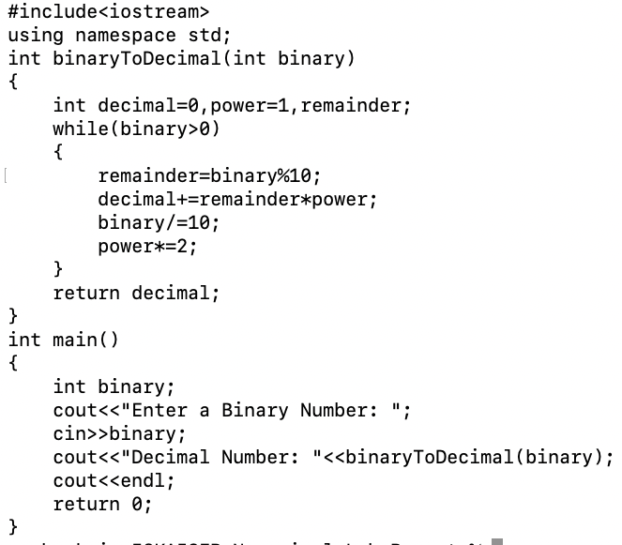
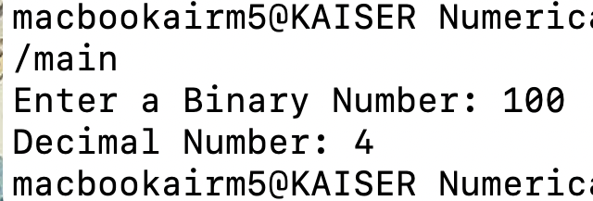

Result Analysis:

When the program was run, a binary number was entered by the user. The digits of the binary number were processed from right to left, and each digit was multiplied by its corresponding power of 2. These values were then added together to find the decimal equivalent. For the input 100, the calculation was done as (1 × 2²) + (0 × 2¹) + (0 × 2⁰), and the final result was obtained as 4. The decimal number 4 was successfully displayed on the screen, which shows that the program worked correctly for the given input.

Problem-02: Convert Decimal number to Binary number.

Key Learnings:

- This program helped in understanding how a decimal number can be converted into a binary number. It showed that a decimal number is repeatedly divided by 2, and the remainders are used to form the binary equivalent.
- The concept of loops was learned more effectively through this program. The loop continued to run until the decimal number became 0, ensuring that all binary digits were generated correctly.
- The importance of storing and arranging data in the correct order was understood. Since the remainders are obtained from last to first, they must be displayed in reverse order to get the correct binary number.
Source Code: Input &Output:
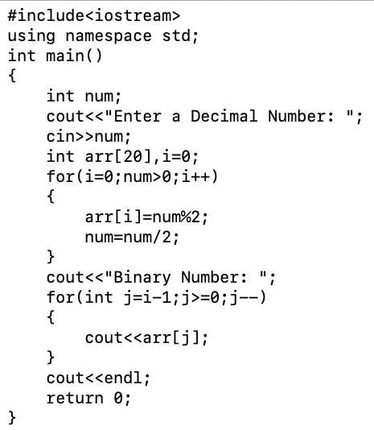
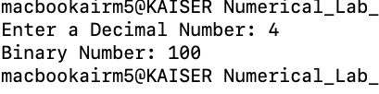

Result Analysis:
When the program was executed, a decimal number was entered by the user. The number was repeatedly divided by 2, and the remainder from each division was obtained. These remainders were stored and later arranged in reverse order to form the binary equivalent. The process continued until the decimal number became 0. As a result, the correct binary representation of the given decimal number was successfully generated and displayed on the screen.

